|  |  |  |  |  |
| --- | --- | --- | --- | --- |
|  |  |  |  |  |

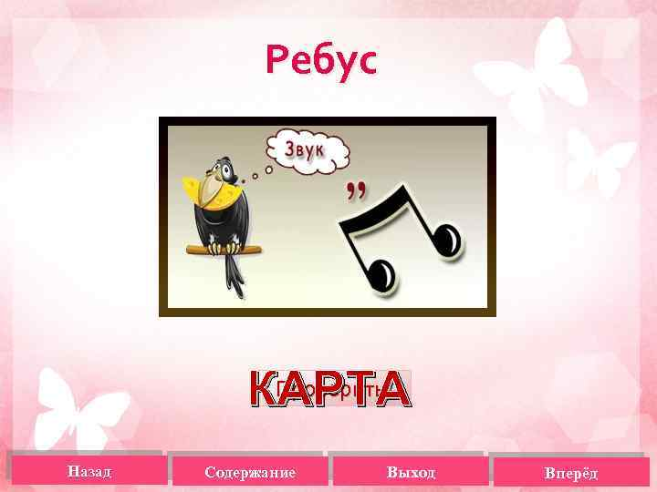

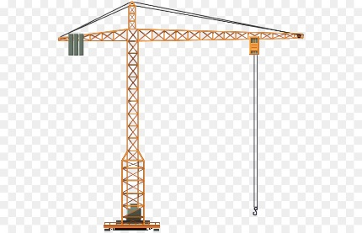 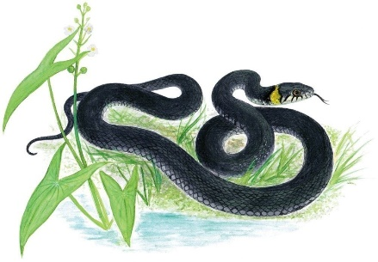 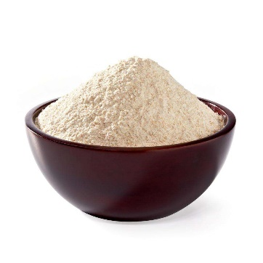

|  |  |  |  |  |  |
| --- | --- | --- | --- | --- | --- |
|  |  |  |  |  |  |

|  |  |  |  |  |
| --- | --- | --- | --- | --- |
|  |  |  |  |  |

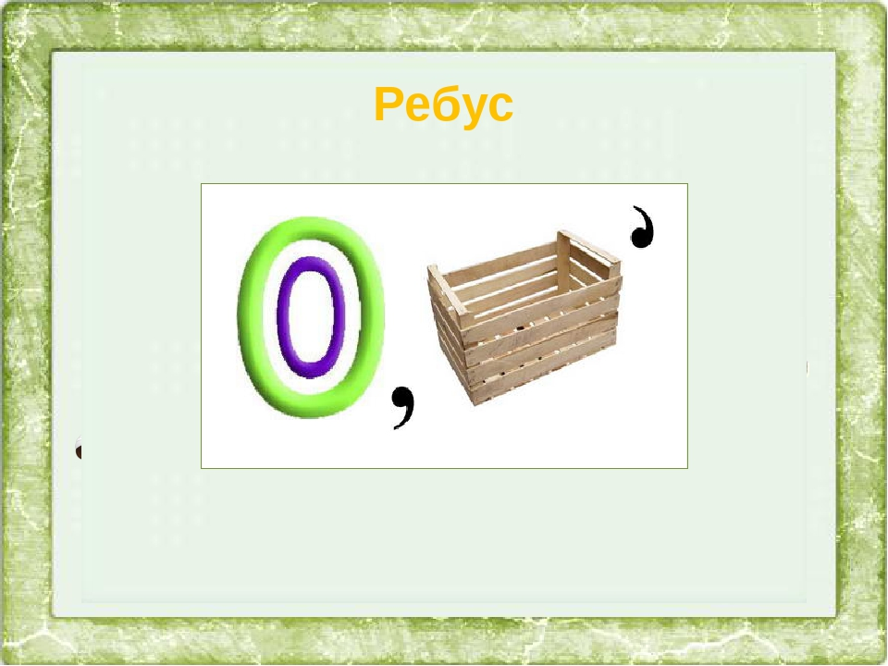

|  |  |  |  |
| --- | --- | --- | --- |
|  |  |  |  |

 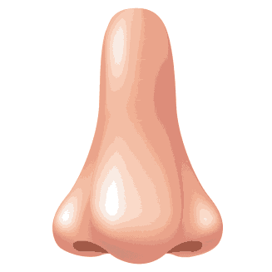

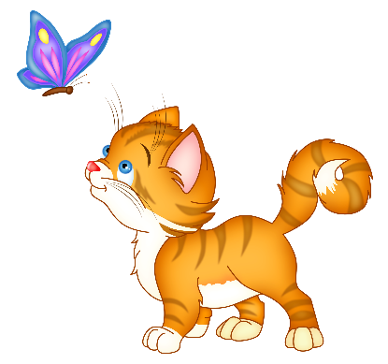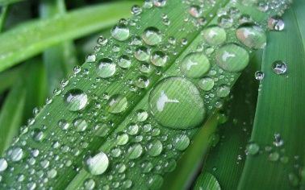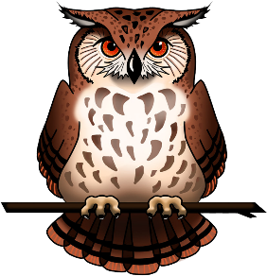 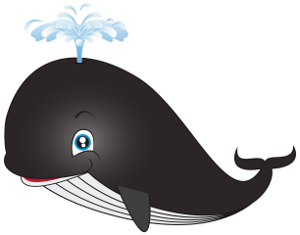

|  |  |  |  |  |  |  |  |  |
| --- | --- | --- | --- | --- | --- | --- | --- | --- |
|  |  |  |  |  |  |  |  |  |

|  |  |  |  |  |  |  |
| --- | --- | --- | --- | --- | --- | --- |
|  |  |  |  |  |  |  |



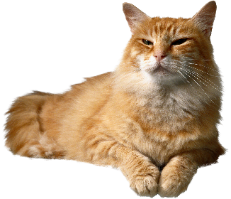 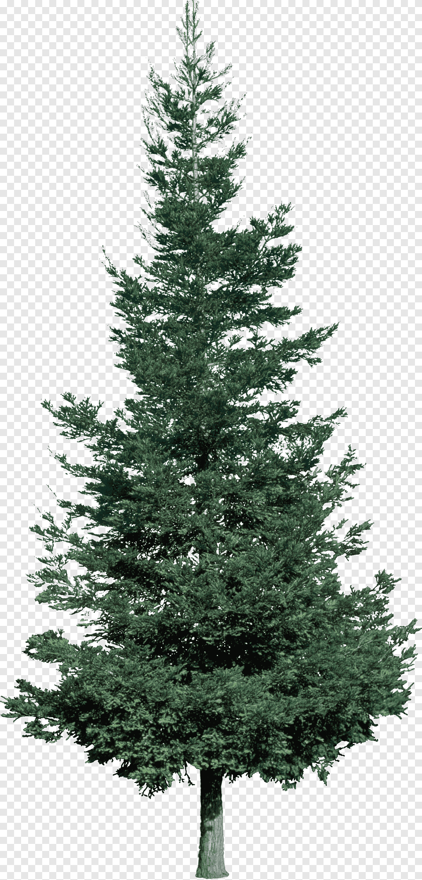 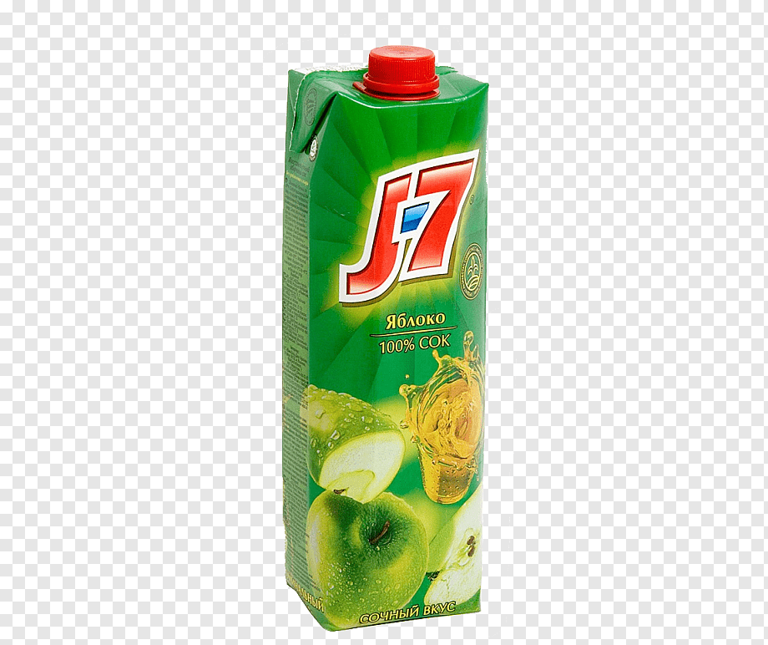

|  |  |  |  |  |  |  |
| --- | --- | --- | --- | --- | --- | --- |
|  |  |  |  |  |  |  |

|  |  |  |  |  |  |
| --- | --- | --- | --- | --- | --- |
|  |  |  |  |  |  |

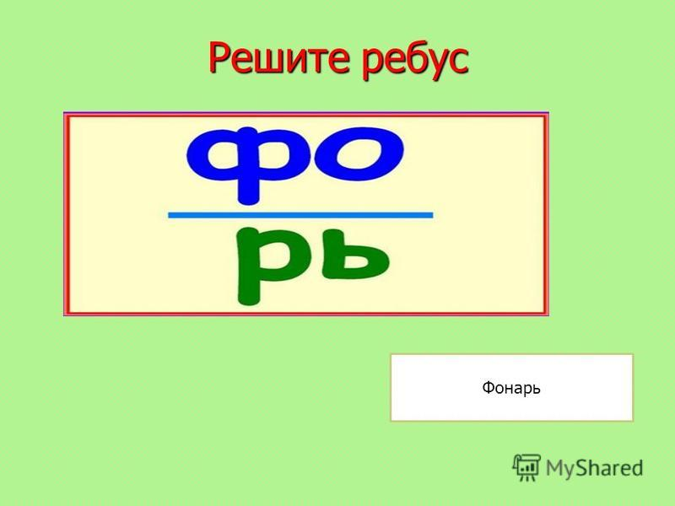

|  |  |  |  |
| --- | --- | --- | --- |
|  |  |  |  |

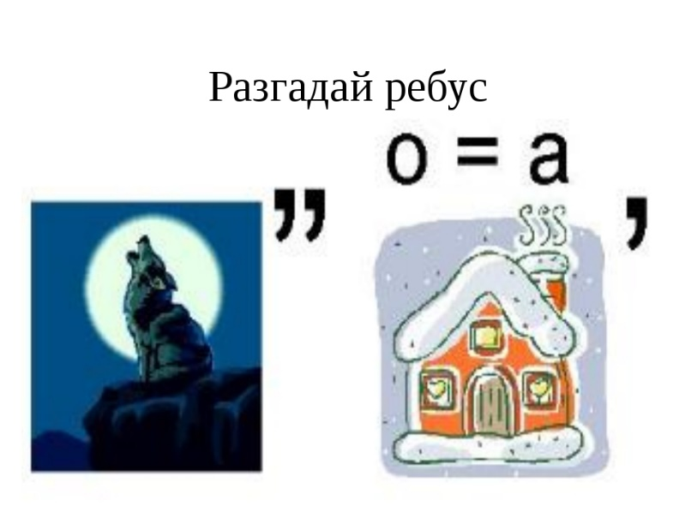

**СЛОВО:**

|  |  |  |  |  |  |  |  |  |
| --- | --- | --- | --- | --- | --- | --- | --- | --- |
|  |  |  |  |  |  |  |  |  |

**1. Реши ребусы и узнай, что возьмет с собой Петя, отправляясь на поиски пиратского клада.**

**2. Что лишнего положил Петя в рюкзак?**

**Какое ключевое слово получилось?**